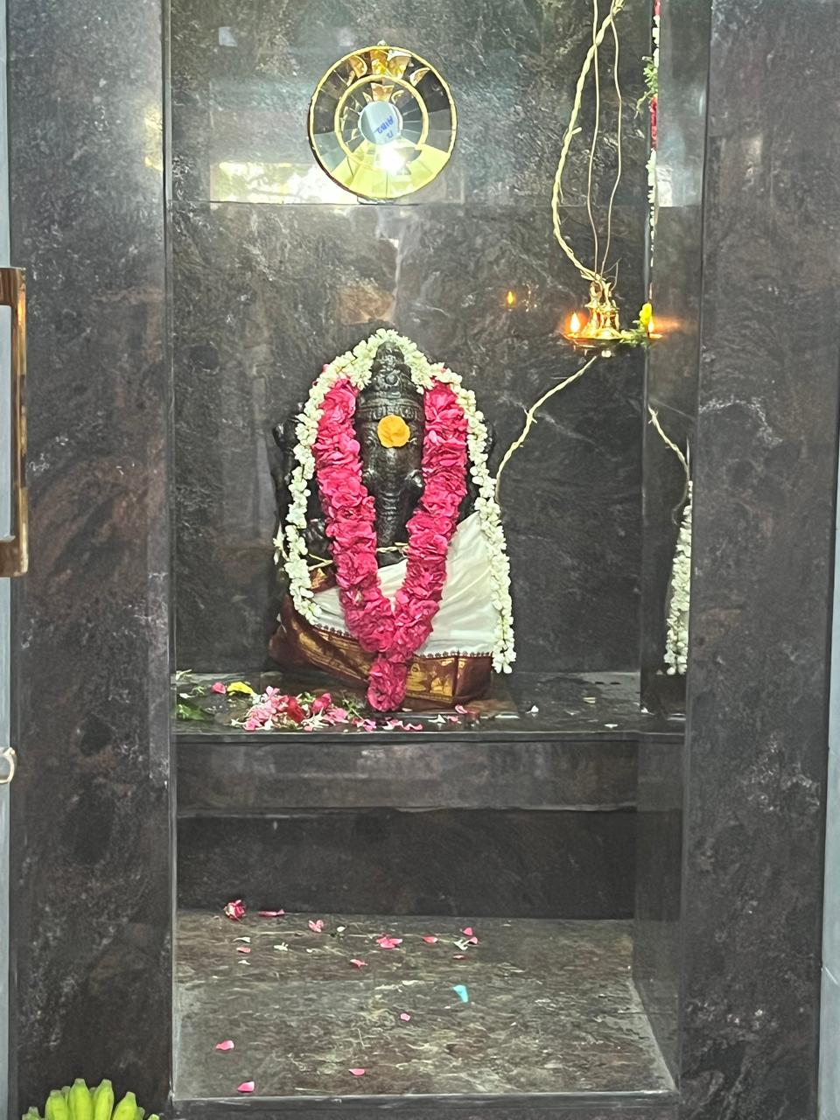
Damodara Pillayar Temple
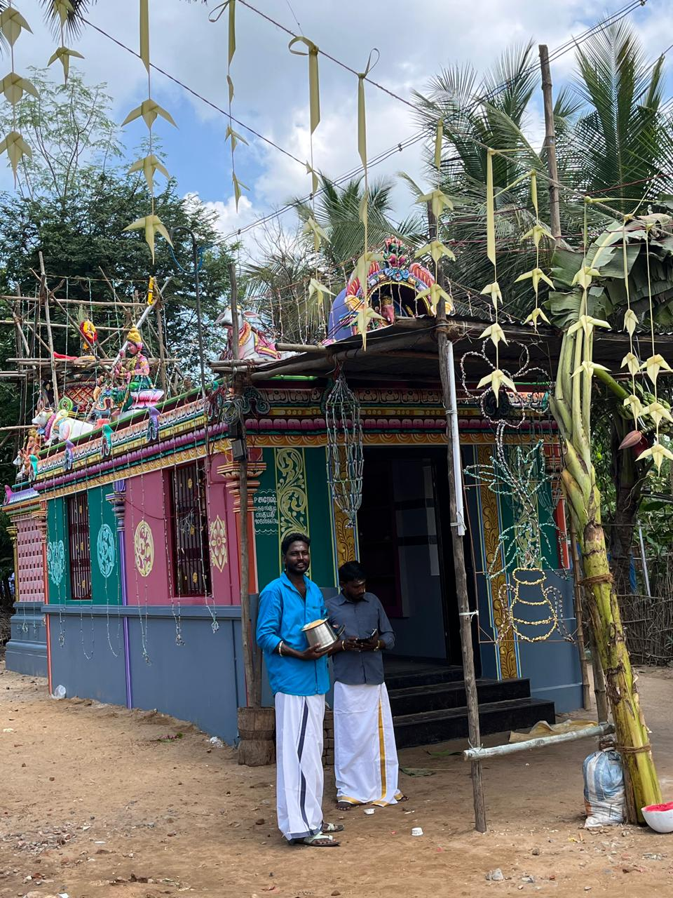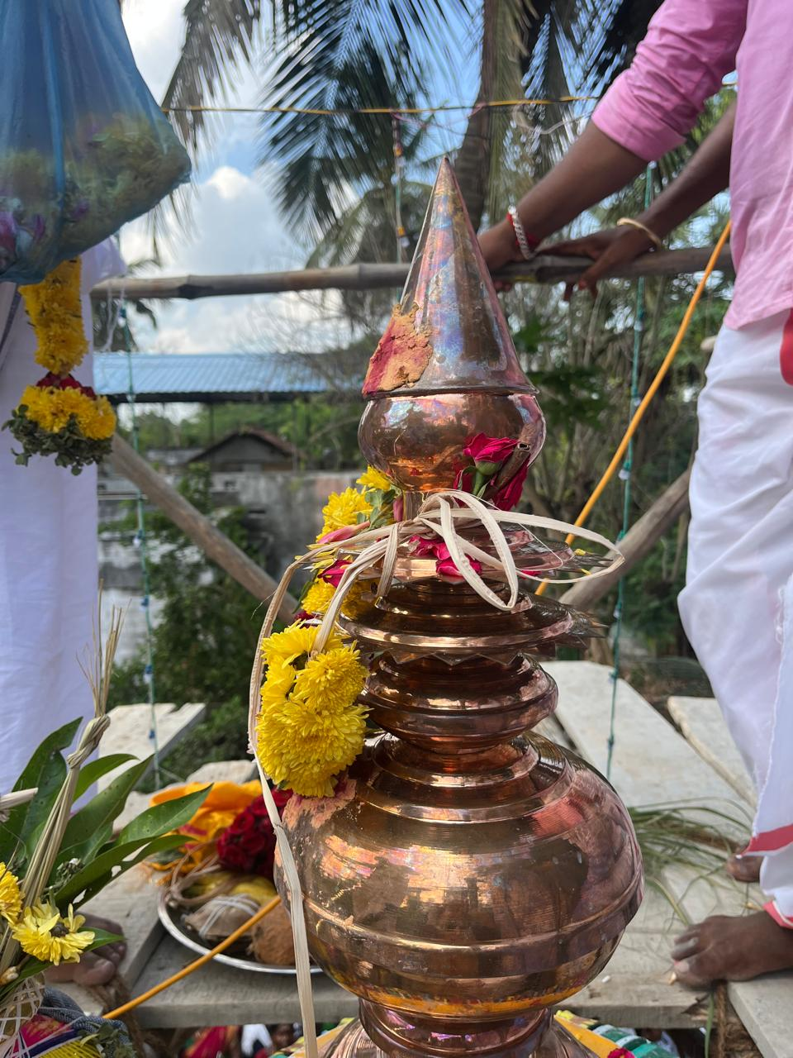

Damodar Pillayar Temple is situated 1 km away from Gnanambal sametha kalahastishwarar temple, towards east side. It is at border of Kakkalany village.
Even today Potters family stay around this temple.
It is said Pannai family ancestors had set this temple.
In year 2025 front side mandapam was renovated & kumbabishekam done by village Pannai family and village families.

